**­­**

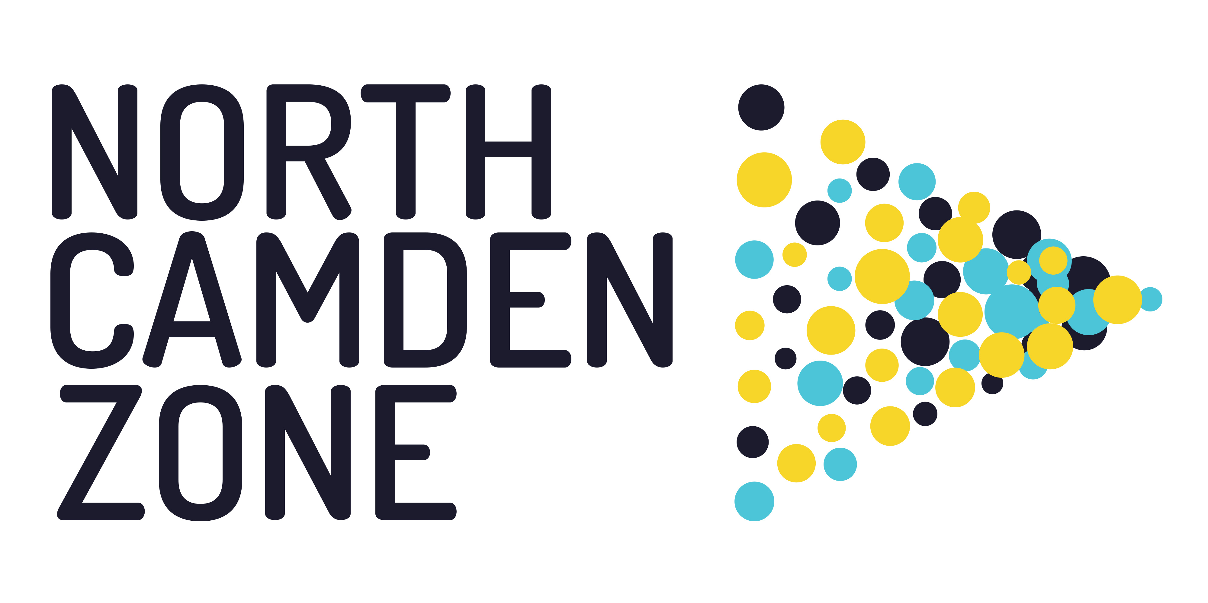

**CHAIR OF THE STEERING GROUP**

**APPLICATION PACK**

Dear applicant,

Thank you for your interest in becoming Chair of the North Camden Zone Steering Group. You will be joining at an exciting time when we are implementing the next phase of this innovative place based systems change initiative.

The North Camden Zone works with the communities, local non-statutory organisations and the statutory sector and businesses to work collaboratively towards a shared vision of a place where children and young people in North Camden can thrive.

We are looking for a Chair of the North Camden Zone Steering Group who will convene and help orchestrate our efforts, be a NCZ ambassador, and work creatively and constructively with the NCZ staff partners and the wider community to secure system level changes, which improve the outcomes for children and young people.

You will be passionate about improving the life outcomes for children and young people living in Camden. You may be a community leader or senior professional with an in depth knowledge and /or experience of the issues that affect children and young people. You are interested in trying a radically different approach and being part of an initiative that is an early adopter of implementing place based systems change. Your experience, skills and networks will enrich and add value to the North Camden Zone.

The application pack should answer all of your questions but if not please do get in touch. We look forward to receiving your application.

**Esther Norman**

**Programme Director, North Camden Zone**  
  


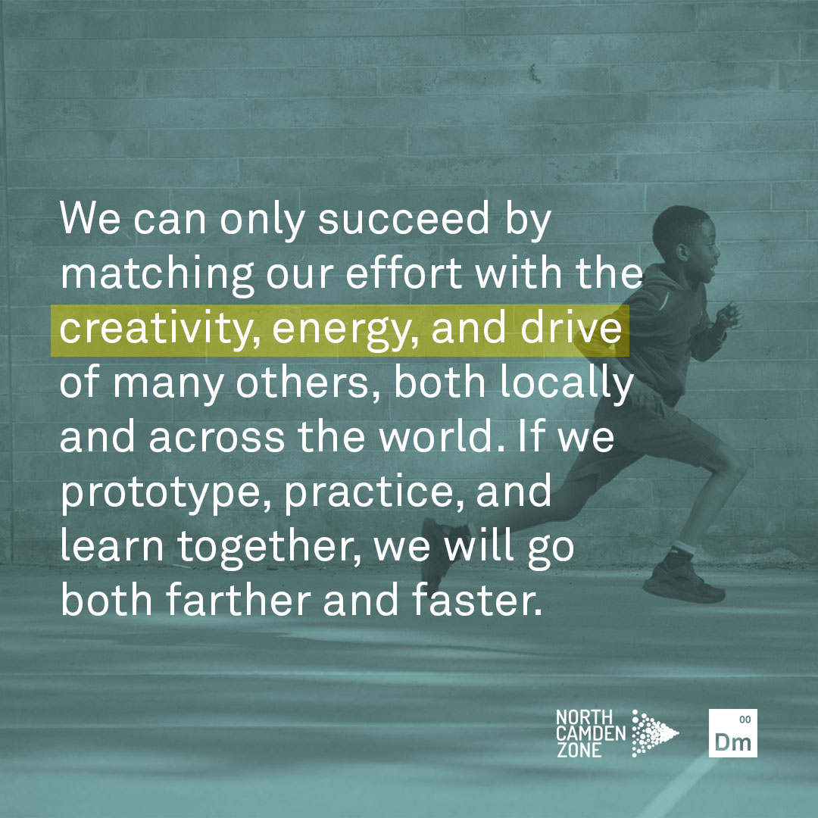**THE NORTH CAMDEN ZONE**

The North Camden Zone is a platform organisation which provides infrastructure and support to organisations and citizens in North Camden to improve the outcomes for children and young people. We create a shared space to bring together organisations and citizens to learn, share ideas, collaborate and test new approaches in order to bring about change that works.

|  |  |
| --- | --- |
|  |  |
| **WHAT IS OUR MISSION?** | A third of children growing up in North Camden are living in poverty. We want to improve the life outcomes for *all* children and young people growing up in North Camden.  We will optimise the conditions for citizens and professionals to achieve systems change and co-create a better future for this and the next generation**.** |
| **WHAT IS OUR AIM?** | We want to build a movementof people that live, work and play, who are passionate about wanting to improve the lives of children in Camden, and have a shared vision and purpose to create sustainable change in North Camden. We want to build an active network of changemakers who want to work together differently. |
| **WHAT IS OUR APPROACH?** | The way we work is underpinned by systems change theory. Poverty is a complex social problem that requires a radically different way of working.  In order to understand and achieve change we need to look at the whole picture.  We need to understand how the systems are organised and interconnected. There are many services, agencies and organisations working with and for children, young people and families in Camden doing valuable work and delivering positive outcomes. However, the way the system is structured is perpetuating economic inequality, poorer life outcomes and fewer opportunities for *some* of the children, young people and families living in Camden.  In order to improve the life chances of *all* children, young people and families, community members and professionals need to commit to taking collective responsibility and action to enable positive change. We need to take a step back, listen to the community, understand what needs to be improved, identify where intervention is most needed and better align how we all work together as whole system.    Children, young people and families are also actors within the system who need to be at the centre of how we understand and co-design new ways of working. They are the experts with lived experience.  North Camden Zone uses an asset based community development approach. We support communities to release their potential, engage in social action and support one another. We will also work with partner organisations to broker their support and unlock the physical and resource assets in the Camden to benefit the community, and support local innovation. |

**BACKGROUND**

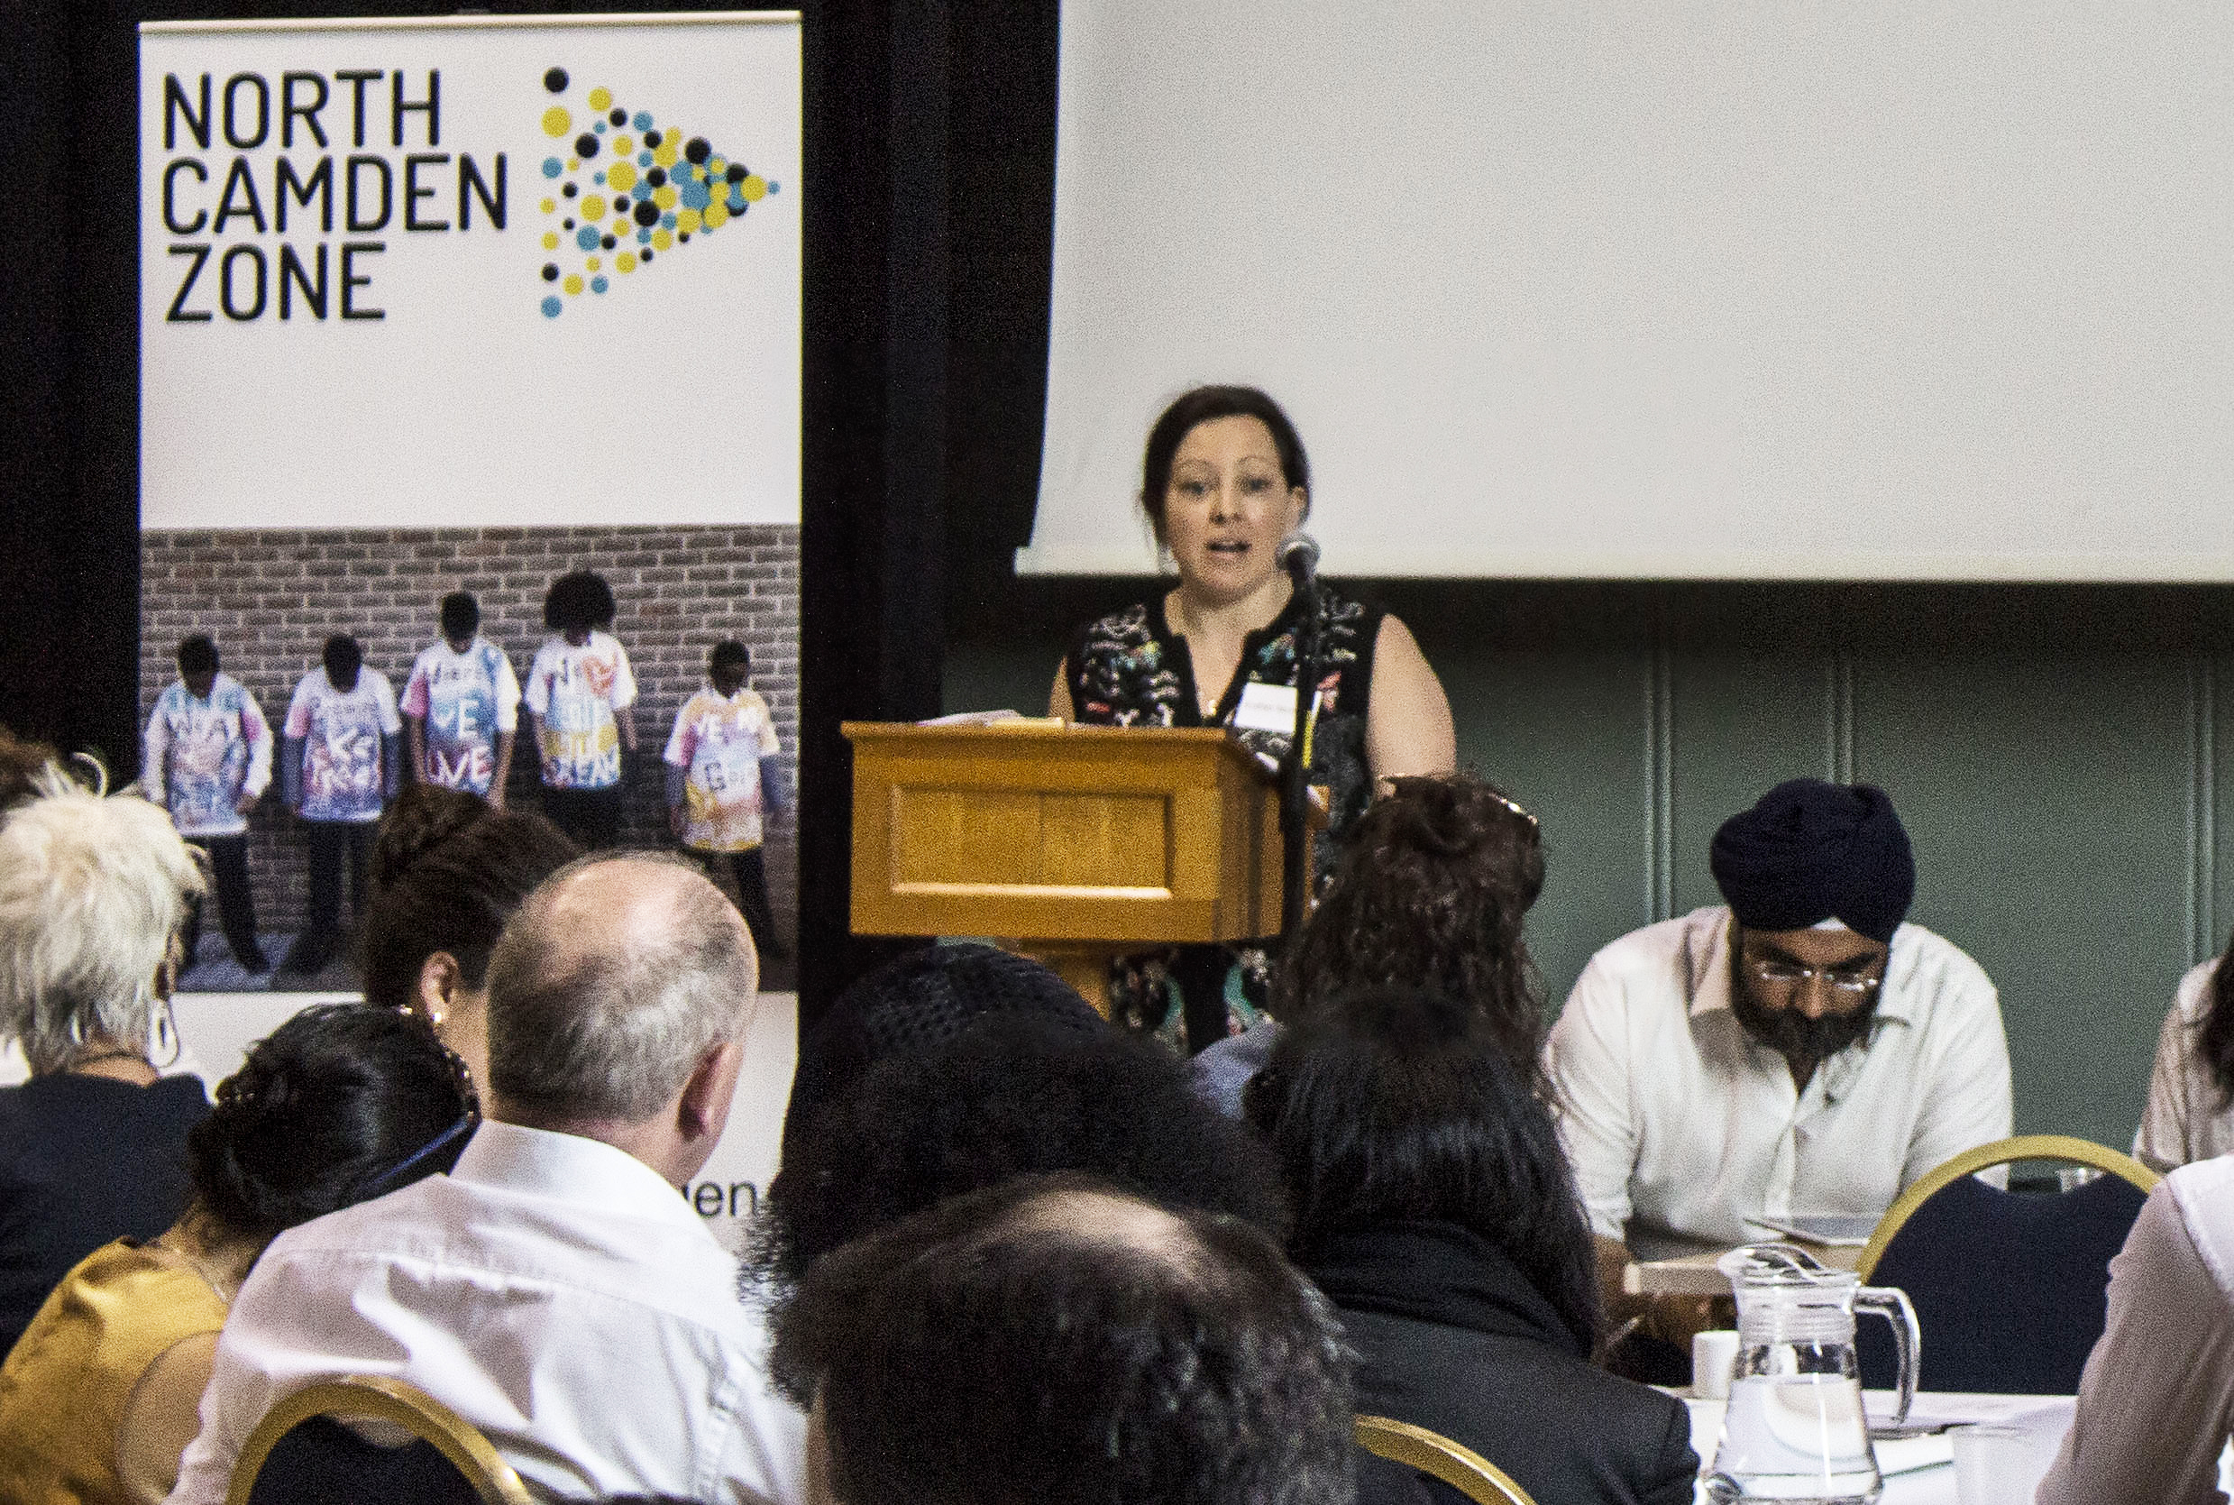

Please read our report [*Building Impact Movements*](http://thewinch.org/wp-content/uploads/2017/07/Building-Impact-Movements.pdf) *which* captures our history and learning to date and outlines our plans for the future.

**THE NORTH CAMDEN ZONE ACTIVITY**

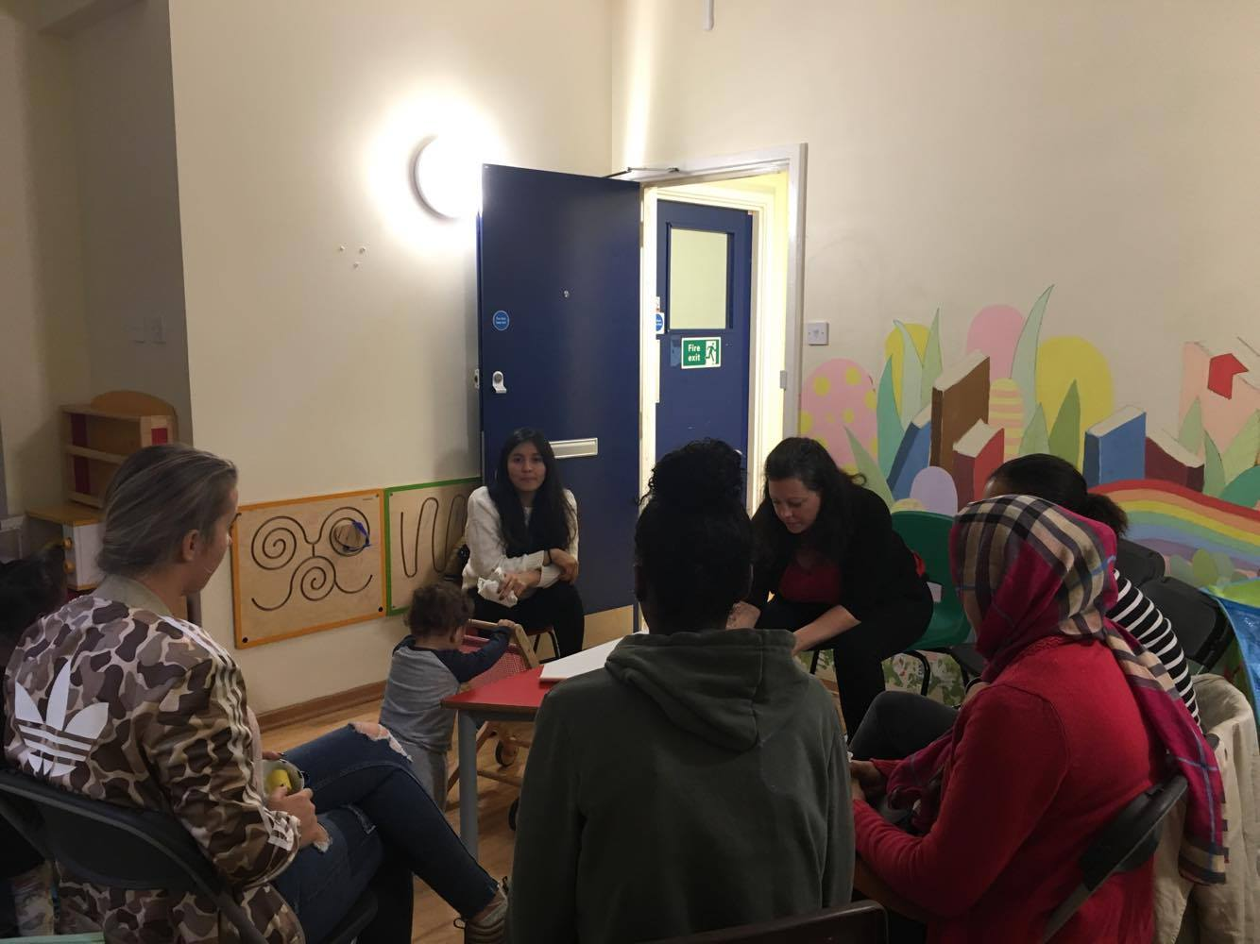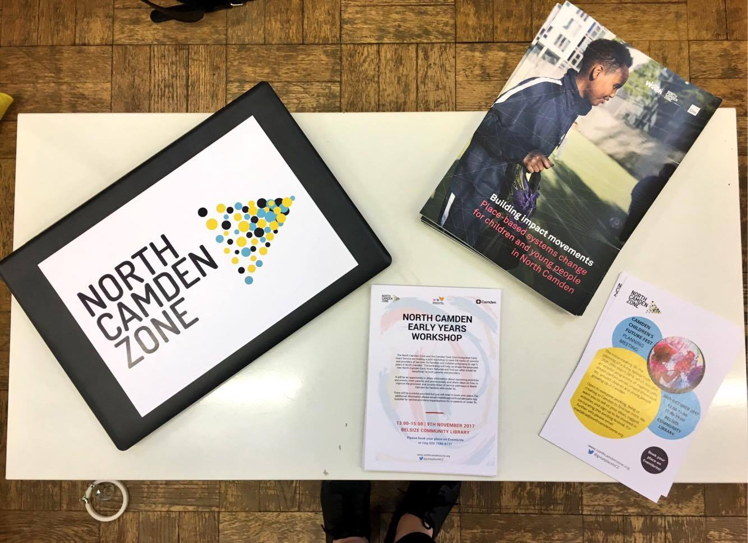

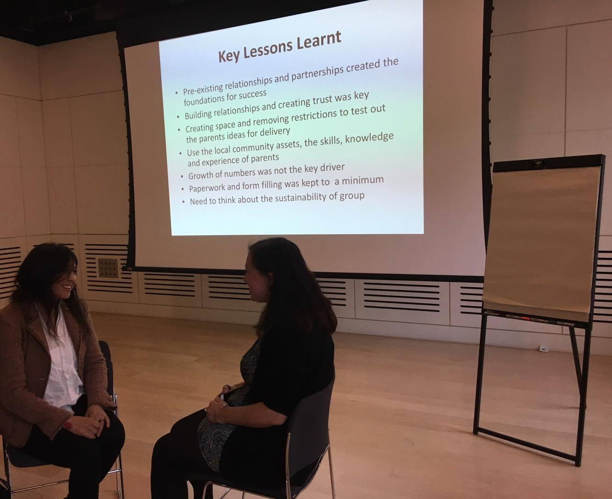

**In the last 2 years we have:-**

* Consulted with 400 children, young people, parents and professionals about growing up in Camden, what could be improved and intervention ideas.
* Trialled and established a community led social action called Connecting Parents, a group for parents and children aged 0-13 years old. This is a peer to peer support group where parents can connect, design and deliver the activities and support one another.
* Delivered a research project on how to improve the transition from primary to secondary school involving the consultation of 117 children, parents and professionals, creating user experience maps and using a co-design process to develop collaborative interventions.
* Ran an arts project in partnership with professional artists and Essential Living. We worked with 7 organisations culminating in 70 children and young people taking part to create a 130 metre hoardings design on the subject of growing up and future aspirations.

**We are currently:**

* Collecting the stories and lived experience of parents and young people living in temporary accommodation
* Initiating a system changers development programme for professionals within Camden
* **In partnership with LB Camden, establishing the North Camden Early Years Network for parents and professionals working with under 5s**
* Developing Camden Children’s Future Fest to be held in March 2018 start a debate, stimulate ideas and inspire action to bring about positive changes for children and young people aged 0 – 25 growing up in Camden now and in the future.

**FUTURE PLANS**

We are looking for funding to implement the next phase which will be to develop a multi-agency, cross sector consortium to build the cultural, technical and organisational capacity of Camden organisations across sectors to work on systems change. North Camden Zone will be the platform to convene, provide the infrastructure and support necessary.

We will begin work in hyper-local areas within North Camden such as some of the local estates including the Chalcot. We will support the conditions necessary for social action to flourish. We want to empower communities to mobilise local assets, be they social or physical. We will use an asset-based form of community development to empower young people, parents and other residents in the area to plan, deliver and sustain social action in their area. We expect this may include community campaigning, providing volunteering opportunities, community decision-making and organising, managing community assets and mutual exchange.

We will provide the platform to foster collaboration between the community, and Camden services and organisations. We will develop the cross-sector partnership to address barriers to social action and release potential in the estates and address the wider system issues, and co-design solutions.

**NORTH CAMDEN ZONE STEERING GROUP**

The NCZ steering group is comprised of representatives of organisations and the community that are passionate and committed to improving the outcomes of children, using this collaborative approach.

**ROLE OF THE STEERING GROUP**

The steering group oversees and advises on the strategic direction of the North Camden Zone project. Through collective decision making is provides a pool of expertise, advice and support to North Camden Zone.

This is the first time that the role of the Chair has been externally advertised and appointed. The Chairing role has historically been held by the Winch CEO.

**RENUMERATION**

All travel and other reasonable expenses incurred whilst in the role of Chair will be remunerated.



The North Camden Zone was incubated and is currently hosted by the charity, the Winch. Ultimately the Winch Board of Trustees is legally responsible for the actions of the North Camden Zone. Therefore, the North Camden Zone Steering Group members are not legally liable or responsible for the North Camden Zone.

The Winch, or The Winchester Project Ltd, is a registered charity (1055059) and company limited by guarantee (03177802). It is governed by charity and company law and in the 2015/16 financial year had a turnover of £862,224.

**THE WINCH BACKGROUND**

Since it was founded in 1973, The Winch has changed the lives of thousands of children and young people working to ensure that growing up below the poverty line doesn’t have to stop young people achieving their potential. In the past, they’ve run an alternative school, a disability motorbike workshop and community festivals whilst providing bespoke support for our most vulnerable families. Today, they support each child from cradle to career through a raft of services and support, ensuring that they’re surrounded by the relationships, opportunities and experiences that will enable them to flourish.

**GOVERNANCE**

The Winch is overseen by a twelve-person Board of Trustees and is chaired by Srabani Sen OBE. Executive leadership is delegated by the Board to Rashid Iqbal, Chief Executive Officer and the Senior Leadership Team.

Line management of the NCZ Programme Director, Esther Norman, is through the CEO of The Winch.

**CHAIR OF THE NORTH CAMDEN ZONE STEERING GROUP**

**Role description**

**Role Title:**                            Chair of Steering Group

**Commitment:**  1-2 days per month

**Term:** 2 years

**MAIN RESPONSIBILITIES**

* Chair and lead the bi-monthly meetings of the North Camden Zone Steering Group
* Be an inspiring ambassador and connector and link North Camden Zone to its stakeholders including residents, public sector, the voluntary and community sector, businesses, funders, etc.
* To regularly meet with the Programme Director, North Camden Zone
* Support the North Camden Zone to achieve a shared and collective purpose
* Commitment to co-creating change to improve the life outcomes of children and young people
* To ensure that both the North Camden Zone staff, the Steering Group and the wider system are held to account for the outcomes that are delivered
* To ensure Steering Group renewal that represents the community and the organisations (recruitment, induction and retirement), effective decision making and information sharing processes, positive group dynamics, and reflection, learning and development as necessary.

**QUALITIES**

**Essential**

* Live or work in Camden or have a strong professional or personal connection.
* Commitment to North Camden Zone’s, aims and values and to a role modelling a systems change approach
* Willingness to devote time to carry out responsibilities.
* Ability to effectively Chair and lead a meeting, be inclusive, seek and hear diverse views, ensure everyone’s voice is heard and is able to make decisions
* Good communication skills.
* Flexible in approach
* Create and support a learning environment
* Good, independent judgement and the ability to think creatively in the context of North Camden Zone and the external environment.
* Willingness to work collectively and collaboratively as part of a group.
* Able to synthesise complexity
* Enabling and empowering to others
* To value the voices of those with lived experience
* Put aside individual or organisational interests to advocate for the bigger picture
* To challenge habits and assumptions

**Desirable**

* Prior experience of Board/Senior Leadership or trustee work.
* Prior experience of being a Chair
* A wider involvement with the voluntary and community sector, public or private sector in Camden.
* Developing or leading a consortium of organisations
* Experience of leading social change or system change work
* Experience of successful fundraising and sustainability planning.

**APPLICATION PROCESS**

**How to apply**

To apply in confidence to become Chair of North Camden Zone, please forward your CV together with a supporting statement. Your statement should fully address the requirements for the role.

You should give the names, positions, organisations and telephone contact numbers of two referees, relevant to this role. References will only be taken up once your express permission has been granted.

Finally, please ensure that you have included mobile, work and home telephone numbers, as well as any dates when you will not be available or might have difficulty with the indicative timetable.

**Timetable**

* Closing date: **Friday, 23rd of February 2018**
* Interviews: **TBC**

**Recruitment Process**

Applications should be emailed to [esther@northcamdenzone.org](mailto:esther@northcamdenzone.org)

Successful candidates will be contacted to come to interview within a week of the closing date.

If you have any questions on any aspect of the appointment process, need additional information or wish to have an informal discussion, please contact Esther Norman, Programme Director on 0207 586 8731 or via email at [esther@northcamdenzone.org](mailto:esther@northcamdenzone.org)